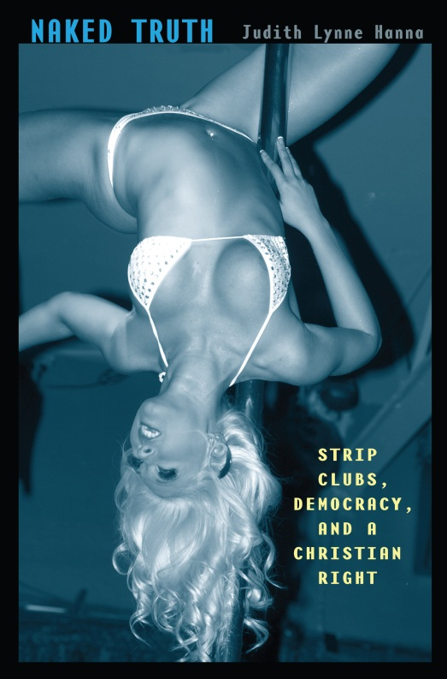
Naked Truth
Strip Clubs, Democracy,
and a Christian Right

by Judith Lynne Hanna

Comments:
http://chronicle.com/blogs/pageview/stripping-as-an-art-form/30473 (review of Naked Truth)
cultureshocks.com (June 1, 2012, Judith Hanna, 40 minute interview about Naked Truth)

http://articles.philly.com/2012-05-24/news/31826970_1_exotic-dance-adult-clubs-dancers (rebuttal to false charges: Tease for two: Exotic dancers aren’t prostitutes)
Michelle Carnes, “Judith Lynne Hanna and ‘Striptease Culture,’” American Anthropologist, Volume 113, Issue 4, pages 648–650, December 2011
http://www.salon.com/2012/05/27/taxing_strip_clubs_for_rape/singleton/ (Hanna quoted)
http://page99test.blogspot.com/2012/04/judith-lynne-hannas-naked-truth.html (Hanna on p. 99)
http://www.bloomberg.com/news/2011-12-05/lap-dances-find-champion-in-academia-as-cities-try-to-rein-in-strip-clubs.html
Sean Carey, “Lap-dancing and moralities in a global world,” anthroworks.com, December 28, 2011
heppas.blogspot.com/2012/04/naked-truth.html
Excerpts:
“Fire, Brimstone, and You,” Exotic Dancer’s Club Bulletin,” March, 2012, pp. 28, 78-79
“Looking on a Woman with Lust is the Same as Committing Adultery,” Exotic Dancer’s Club Bulletin May 2012, pp. 60-62

